Max Gross – Period 8 – Ms. Jones
Study Guide for Static Electricity Quiz
- Name the parts and location of the parts of the atom
1A.
- Part: Protons
- Charge: Positive
- Location: Inside the nucleus with neutrons
1B.
  - Part: Neutrons
  - Charge: Neutral/ no charge at all
  - Location: Inside the nucleus with protons
1C.
A. Part: Electrons
B. Charge: Negative
C. Location: Outside and orbiting the nucleus
- What holds the electrons in the orbits of the nucleus?
The attraction of the negative electrons that orbit the nucleus and the positive protons that is inside the nucleus is what holds the electrons in the orbits of the nucleus.

- Electric force/electric field- is when when objects repel or attract

- What effects the strength of an electric field (2 things)
The two things that effect the strength of an electric field are:
- Amount – the greater the charge is, the greater the electrical force is.
- Distance – The closer together charges are, the greater the electrical force is.

- Electroscope- a device that is used to see if something is charged. It cannot show if am object has a positive or negative charge. It is a container that has a knob on the top. There are two metal strips inside the container called leaves. The leaves hang straight down when no electrical charges are present.

- Electric Discharge-
Electric Discharge is the loss of static electricity as charges move off an object.
An example of electric discharge is lightning. One of the causes of electric
discharge is static electricity. Another example of electric discharge is induction,
when the charges in an uncharged metal object are rearranged without direct
contact.
with a charged object.
7. Forces of attraction/repulsion – when do each occur?
Forces of Attraction occur when two particles are oppositely charged (negative
and a positive charges). Forces of Repulsion occur when two particles have the
same charge (negative and negative charges or positive and positive charges)

8. 3 ways to charge an object
  - friction – this is when electrons are “wiped” from one object to another/ surfaces rub and there is an electron transfer.
  - induction – this is when charges in an uncharged metal object are rearranged without direct contact with a charged object and there is no electron transfer.
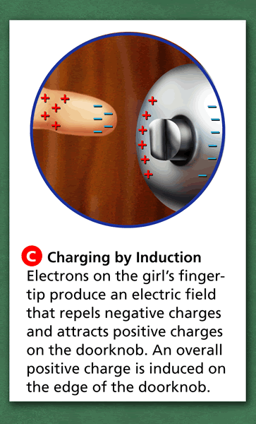
  - Conduction – this is what happens when electrons move by direct contact and there is an electron transfer.

  - What is Static electricity?
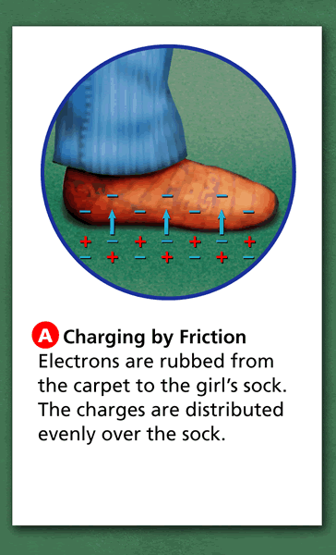
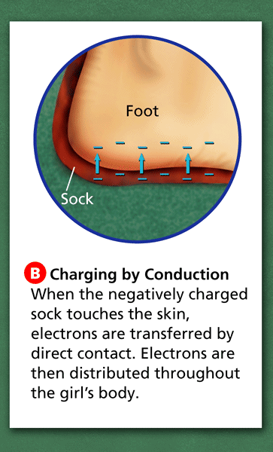
Static electricity is the electric charge at rest on an object. If something is static it isn’t moving.

10. Transferring Charge Example

